**Sensors**

An input device, module, or subsystem whose purpose is to detect events or changes in its environment and send the information to other electronics, frequently a [computer processor](https://en.wikipedia.org/wiki/Computer_processor). It makes a translation between the physical world to microcontrollers. A sensor is always used with other electronics, whether as simple as a light or as complex as a computer.

There are digital or analogue sensors.

Analog sensors capture analog signals that can assume any value in a range. An interesting way to think about this is that an Analog Signal works like a tuner on an older radio. You can turn it up or down in a continuous motion. You can fine tune it by turning the knob ever so slightly. In order to successfully use an Analog sensor, you need some way to convert the data into a digital form. For example: this sound sensor is used to sense sound level, i.e., it translates the amplitude of the acoustic volume of the sound into an electrical voltage for sensing sound level. This process requires some circuitry, and utilizes microcontroller along with a microphone for creating an analog output signal.

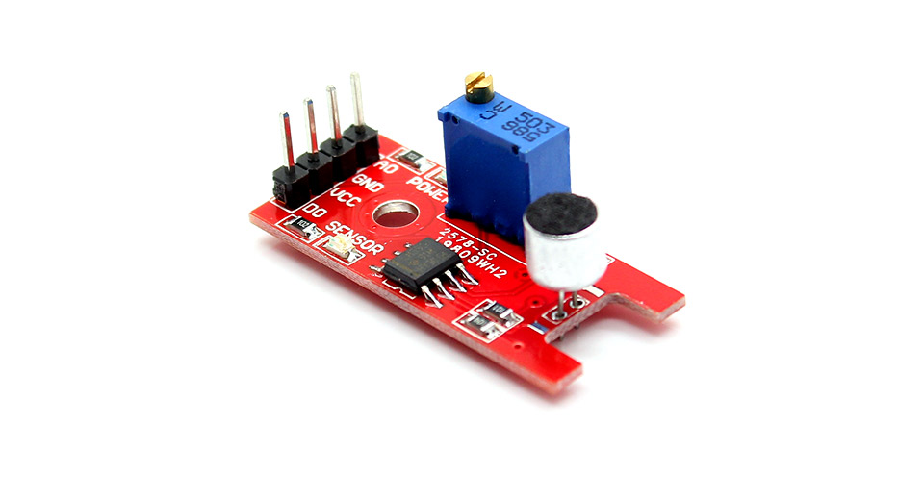

Digital sensors generate what is called a 'Discrete Signal'. This means that there is a range of values that the sensor can output, but the value must increase in steps. There is a known relationship between any value and the values preceding and following it. For example, consider a push button switch. This is one of the simplest forms of sensors. It has two discrete values. It is on, or it is off. Other 'discrete' sensors might provide you with a binary value. The most common discrete sensors used in robotics provide you with a binary output which has two discrete states. The same sound sensor of the picture can produce digital and analog signals.

The digital sensor consists of majorly three components: sensor, cable, and transmitter. In digital sensors, the signal measured is directly converted into digital signal output inside the digital sensor itself. And this digital signal is transmitted through cable digitally. There are different types of digital sensors that overcome disadvantages of analog sensors.

The distinction between Analog and Digital is important when you are deciding which type of sensor you wish to use. Part of this decision depends on the type of resources available on your Microcontroller.